User Guide — AI Coach

Overview
AI Coach is an AI learning assistant that personalizes content and learning paths based on your level, learning style, and goals — from your first steps exploring AI all the way to earning a professional certification and applying AI to real work.
What sets AI Coach apart:
- Understands you: remembers your level, role, preferences, and goals so every answer is pitched at the right level.
- Has a roadmap: builds and tracks a personal learning path, rather than just answering isolated questions.
- Tied to your work: helps you shape a real work situation into a safe, compliant AI use case.
──────────────────────────────────────────────────

Interface layout
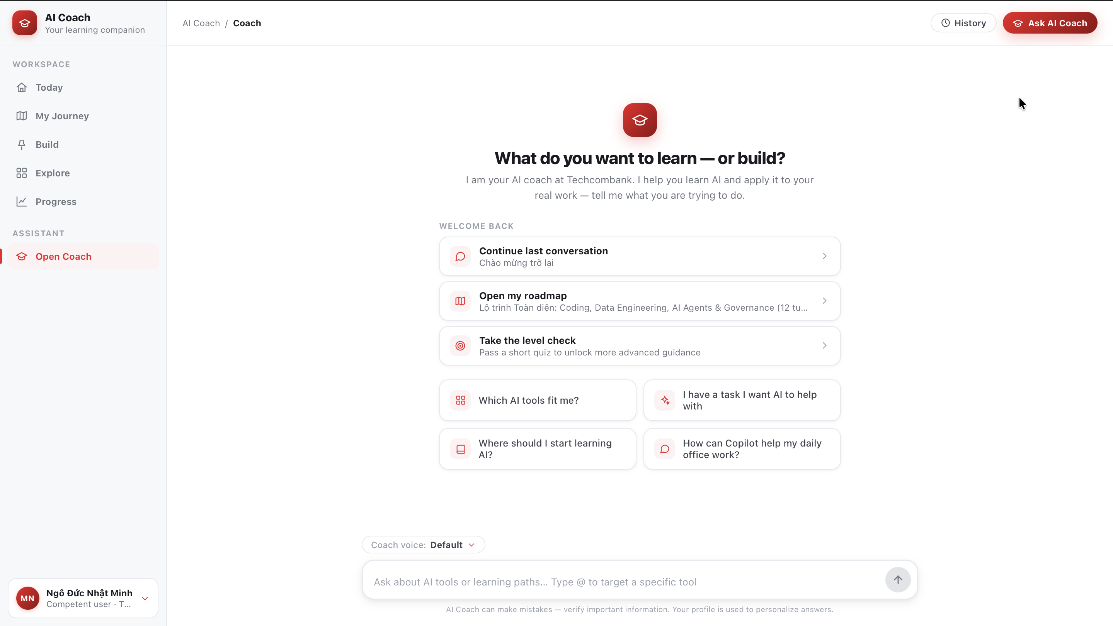
The interface has a left navigation bar (sidebar) and a main content area on the right.
The left sidebar is split into 2 groups:
Group | Item | Function
WORKSPACE | Today | Daily home — what to do next, a short daily mission, and an overall progress snapshot
 | My Journey | Your active personal learning path
 | Build | Shape a real work situation into a safe AI use case
 | Explore | Discover AI tools and certifications
 | Progress | Track your growth with evidence
ASSISTANT | Open Coach | Open a direct chat with AI Coach
The top bar (shown on every page):
- Breadcrumb — your current location (e.g. AI Coach / Coach).
- History — review your past conversations.
- Ask AI Coach — quickly open a chat from any page.
The bottom-left corner shows your profile: your name and current level (e.g. "Competent user"). It's a shortcut to view/edit your learning profile.
──────────────────────────────────────────────────

First-time setup
On your first visit, you go through 3 quick setup steps ("Personalize your AI Coach"). Each answer helps Coach tune content to your exact level, role, and language.

Step 1 — Your level
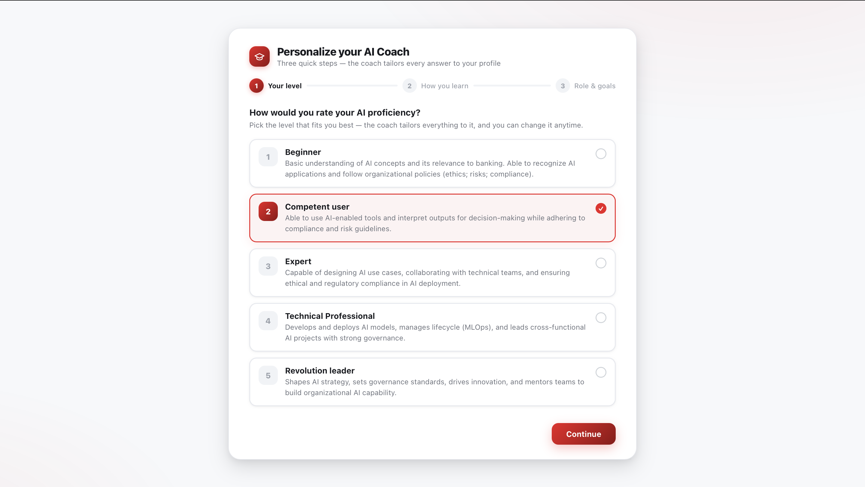
Choose 1 of 5 AI levels (from Beginner to Revolution leader). All content and recommendations in the app are personalized to the level you choose.

Step 2 — How you learn
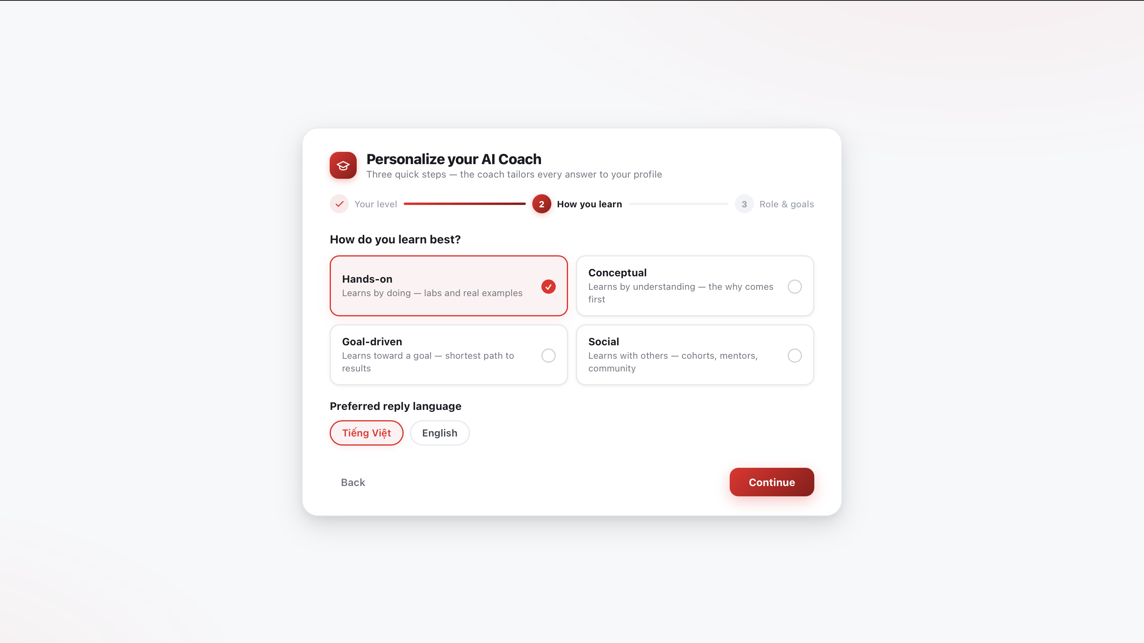
Choose how you learn best:
- Hands-on — learn by doing, through labs and real examples.
- Conceptual — understand the essence first; the "why" comes first.
- Goal-driven — learn toward a goal, the shortest path to results.
- Social — learn with others, through cohorts, mentors, and community.
Then choose your preferred response language: Vietnamese or English.

Step 3 — Role & goals
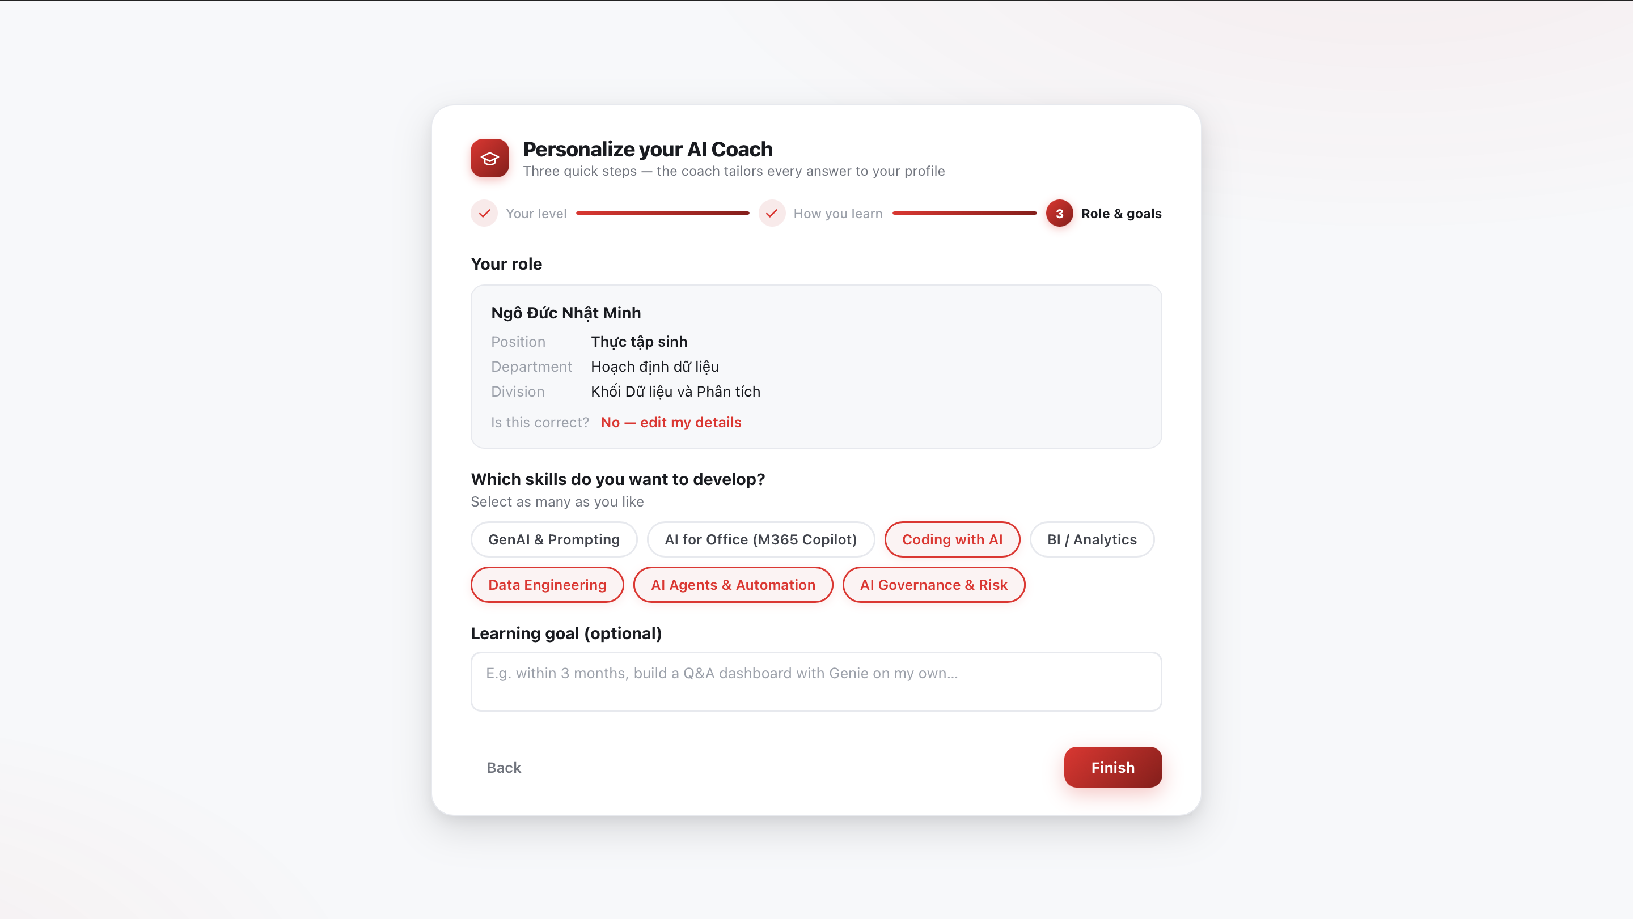
- Your role: information from your HR profile is pre-filled (full name, position, department, division). If it's not right, click "No — edit my details" to adjust.
- Which skills do you want to develop?: select as many as you like — GenAI & Prompting, AI for Office (M365 Copilot), Coding with AI, BI / Analytics, Data Engineering, AI Agents & Automation, AI Governance & Risk.
- Learning goal (optional): enter a specific learning goal (e.g. "in 3 months, build a Q&A dashboard with Genie on my own").
Click Finish to complete setup and enter the Today page.
──────────────────────────────────────────────────

Today — Daily home
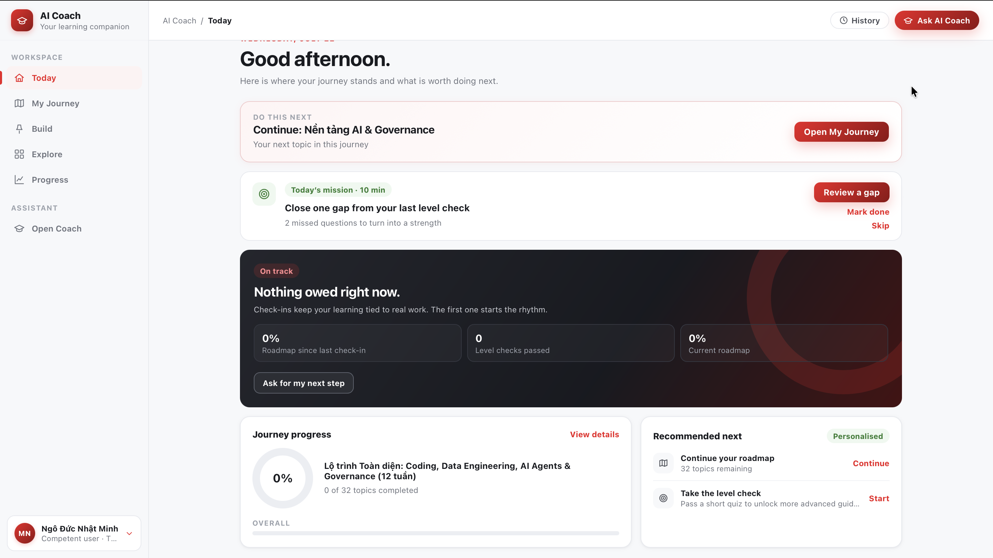
Today is your starting point each day, summarizing what to do and your learning status on a single page:
- Do this next — what to do next, suggesting your immediate next action in the roadmap.
- Today's mission — a short task (about 10 minutes) to keep your learning habit going.
- Check-in panel ("On track" / "Nothing owed") — whether you're keeping up with your roadmap, along with metrics like roadmap progress and the number of Level Checks passed.
- Journey progress — a doughnut chart showing your roadmap completion percentage.
- Recommended next — suggestions for the next step: continue the roadmap or take a Level Check.
──────────────────────────────────────────────────

Open Coach — Chat with AI Coach
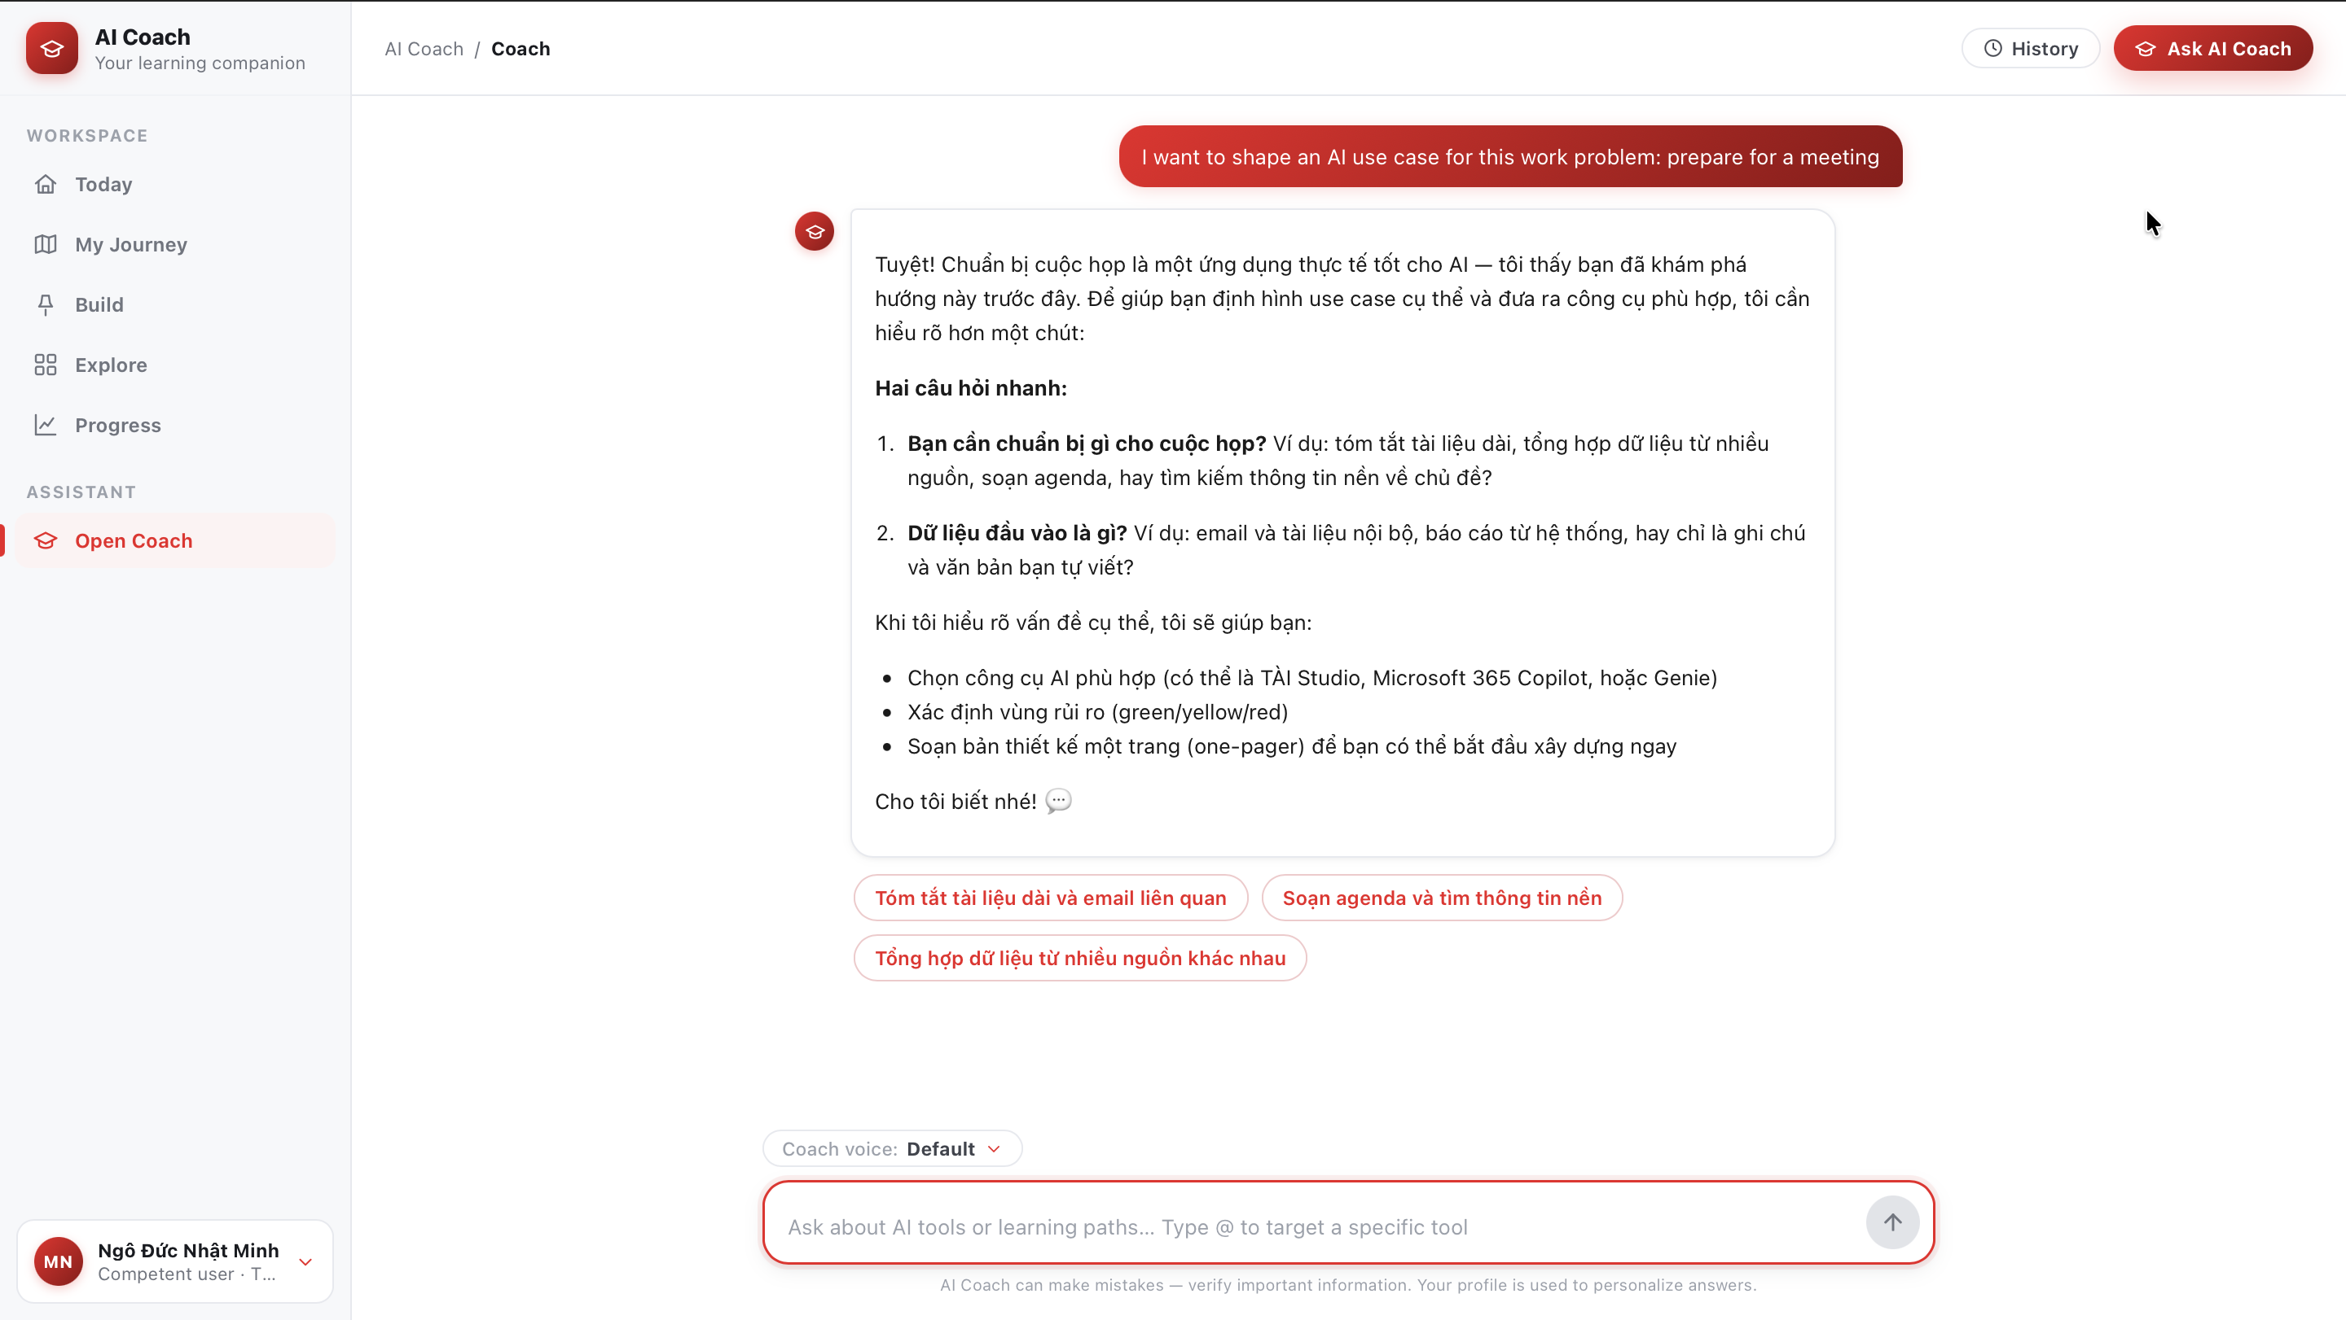
This is where you ask questions, learn, and ask Coach to build a roadmap.
Chat list (left of the Coach panel): a New chat button to start a new conversation, plus a Recent list of saved conversations (reopen any of them anytime).
Coach voice: just above the input box there's a menu to pick the response style that fits your needs:
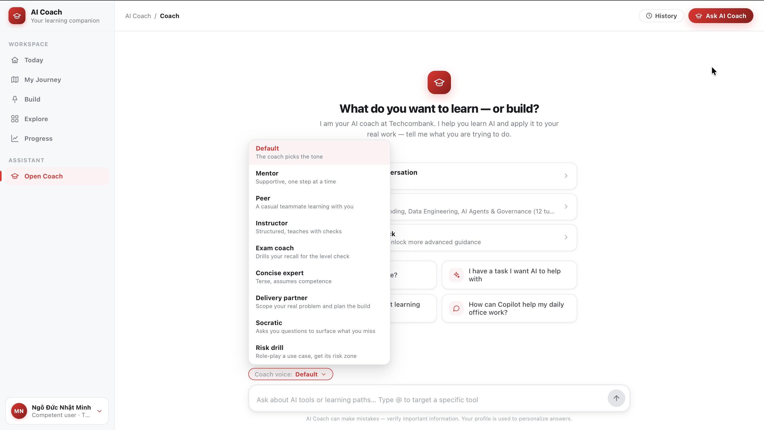
Voice | When to use
Default | Coach picks a suitable voice automatically
Mentor | Gentle, step-by-step support
Peer | Like a teammate learning alongside you, casual
Instructor | Structured, teaches with checks
Exam coach | Drills recall to prepare for a Level Check
Concise expert | Brief, assumes you already have the fundamentals
Delivery partner | Helps scope the real problem and plan the rollout
Socratic | Asks probing questions so you spot the gaps yourself
Risk drill | Role-plays a use case and identifies its risk zones
Mention a specific tool: type @ in the input box to direct your question at a specific AI tool (e.g. @TÀI Studio).
Note: Coach may answer inaccurately — always verify important information. Your profile is used to personalize answers.
──────────────────────────────────────────────────

My Journey — Personal learning path
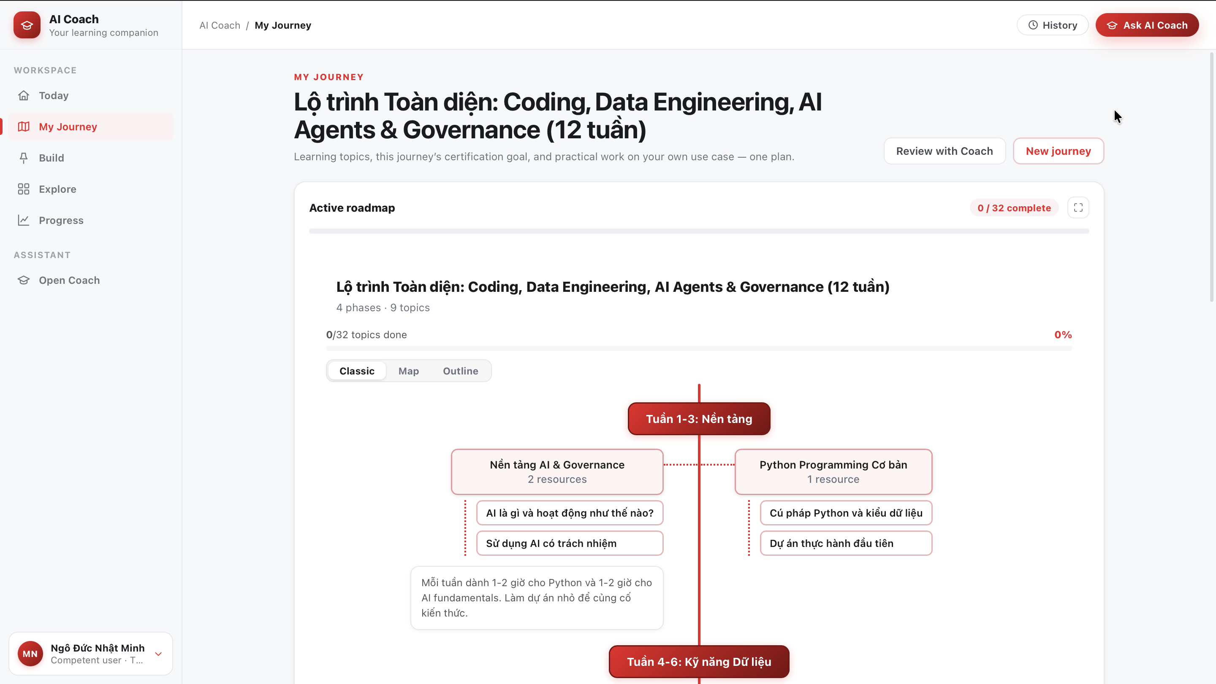
This page shows your active learning path and lets you track and edit your progress.
Main components:
- Active roadmap — the path you're following, with the number of completed nodes ("X / Y complete") and a percentage progress bar.
- Action buttons at the top:
- Review with Coach — ask Coach to review your path and suggest adjustments (opens Coach with a prepared question).
- New journey — create a new learning path.
- Right column:
- Active certification goal — the certification you're targeting (links to Explore).
- Open commitments — commitments/tasks still in progress.
View mode: the path shows in Classic view by default (the familiar phase map). You can change the view using the toggle at the top of the path if you want a different layout.
Update each node's progress: each node has 4 states, switched quickly with keyboard shortcuts:
Key | State | Meaning
T | Not started | Not started yet
L | In progress | Currently learning
D | Done | Completed
S | Skipped | Skipped
When you mark a node "Done", the path's completion percentage increases accordingly.
When you click a node/topic: a detail panel opens with these actions:
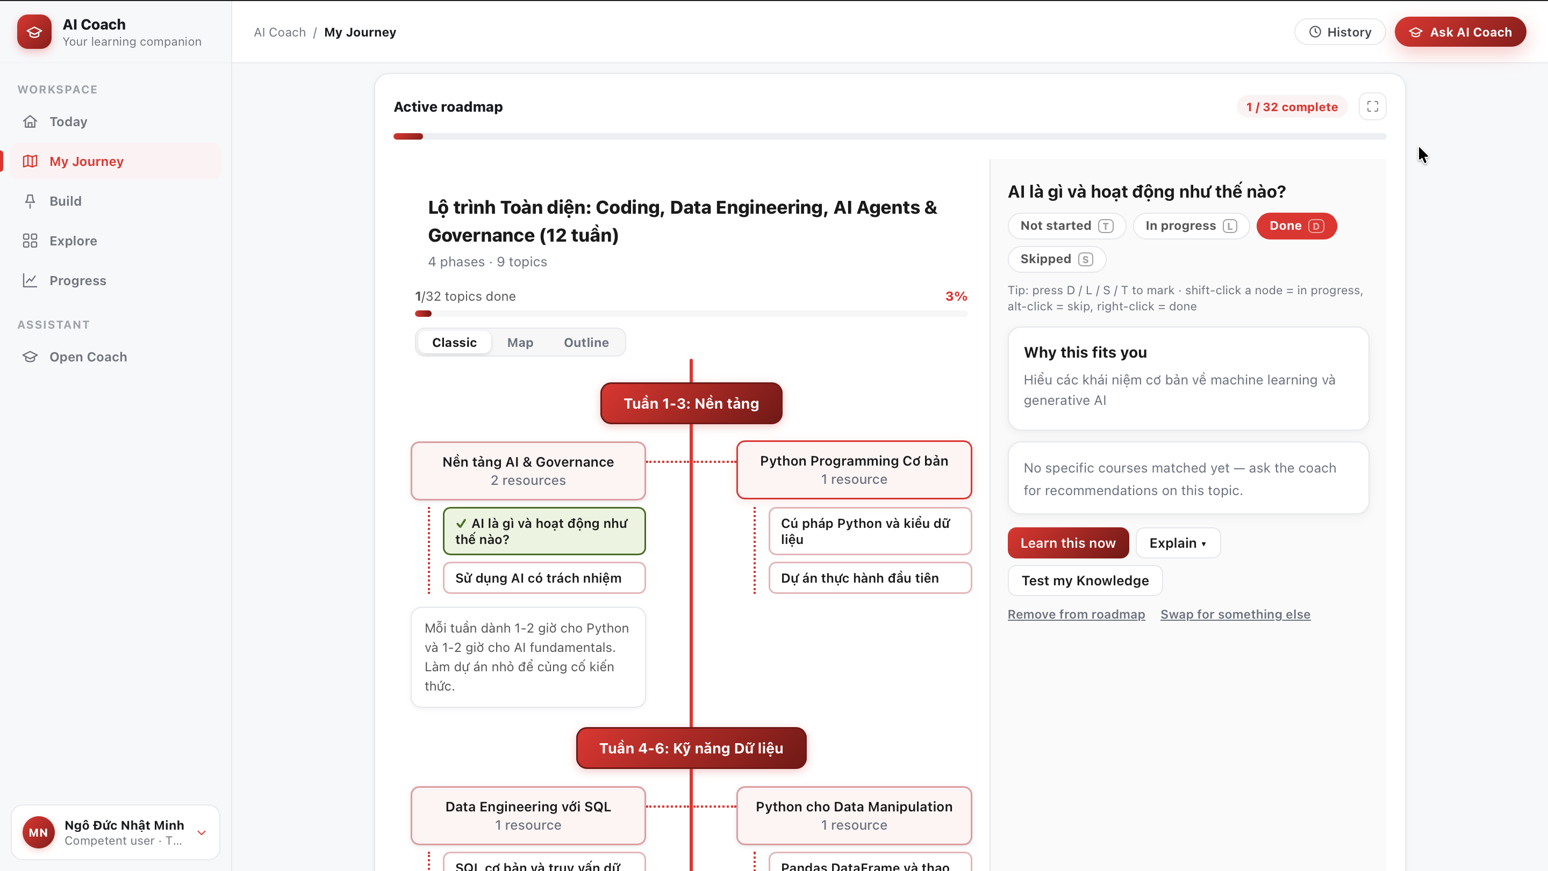
- Learn this now — start learning the topic right away.
- Explain — Coach explains more about the topic.
- Test my Knowledge — check your level of understanding.
- Remove from roadmap — remove the topic from the path if it doesn't fit.
- Includes the recommended course for the topic (course name, source) when available.
──────────────────────────────────────────────────

Build — Shape a safe use case
Build helps you turn a real work situation into a clearly shaped, compliant AI use case. The page has 2 states.

State 1 — Describe the work
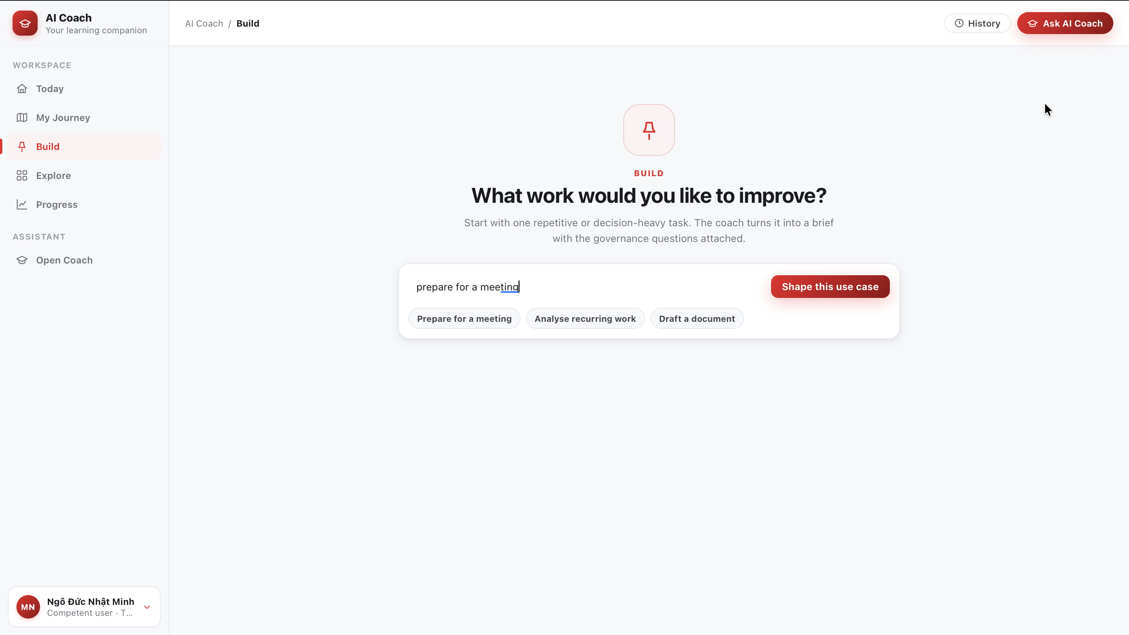

The screen asks "What work would you like to improve?" with an input box and a Shape this use case button. Quick suggestions are available to get started:
- Prepare for a meeting
- Analyse recurring work
- Draft a document
When you click Shape this use case (or pick a suggestion), Build moves your request into a chat with Coach. Coach asks a few short questions to clarify the context and governance factors (e.g. what type of work it is, what exactly you need to produce), then helps shape the use case and suggests suitable AI tools.

State 2 — Shape a safe solution
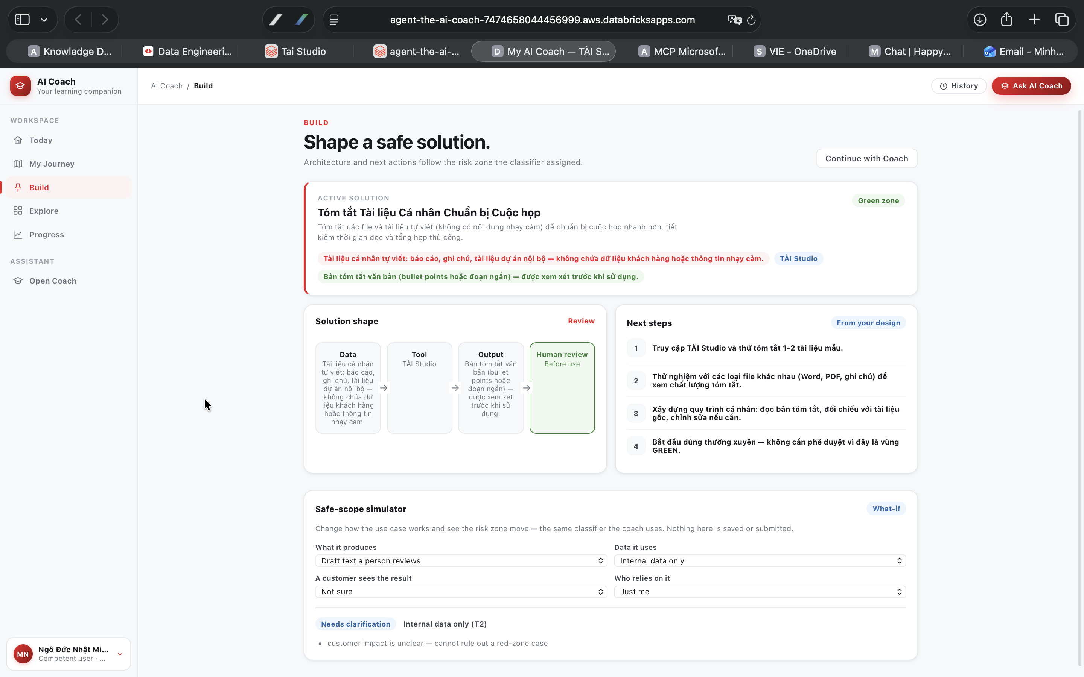
After talking with Coach, the Build page becomes "Shape a safe solution" — a draft solution tied to the risk zone the system classifies:
- Draft solution — a draft use case with a risk-zone label (e.g. Green zone) and a status ("Coach is still gathering information for the brief").
- Solution shape — a sequence of steps: Data → Tool → Output → Human review, each with a status to confirm ("To confirm" / "Before use"), plus a Review link.
- Next steps — next steps are sketched out progressively as you keep chatting.
- Safe-scope simulator (What-if) — a simulation tool: change the choices to see how the risk zone shifts (using the exact classifier Coach uses). The criteria include:
- What it produces — what the output is (e.g. a human-reviewed draft).
- Data it uses — which data is used (e.g. internal data only).
- A customer sees the result — whether a customer sees the result.
- Who relies on it — who depends on this result.
- The simulation shows a tier label (e.g. tier T2) and warnings that need clarification. This is only a trial ("preliminary — not an approval") — it is not an approval and is not saved or sent anywhere.
- Continue with Coach — go back to the chat to keep refining.
──────────────────────────────────────────────────

Explore — AI Tools & Certifications
The Explore page has a toggle between AI Tools and Certifications (top right), plus an All / Unlocked for me filter (shows only items unlocked for you).

AI Tools
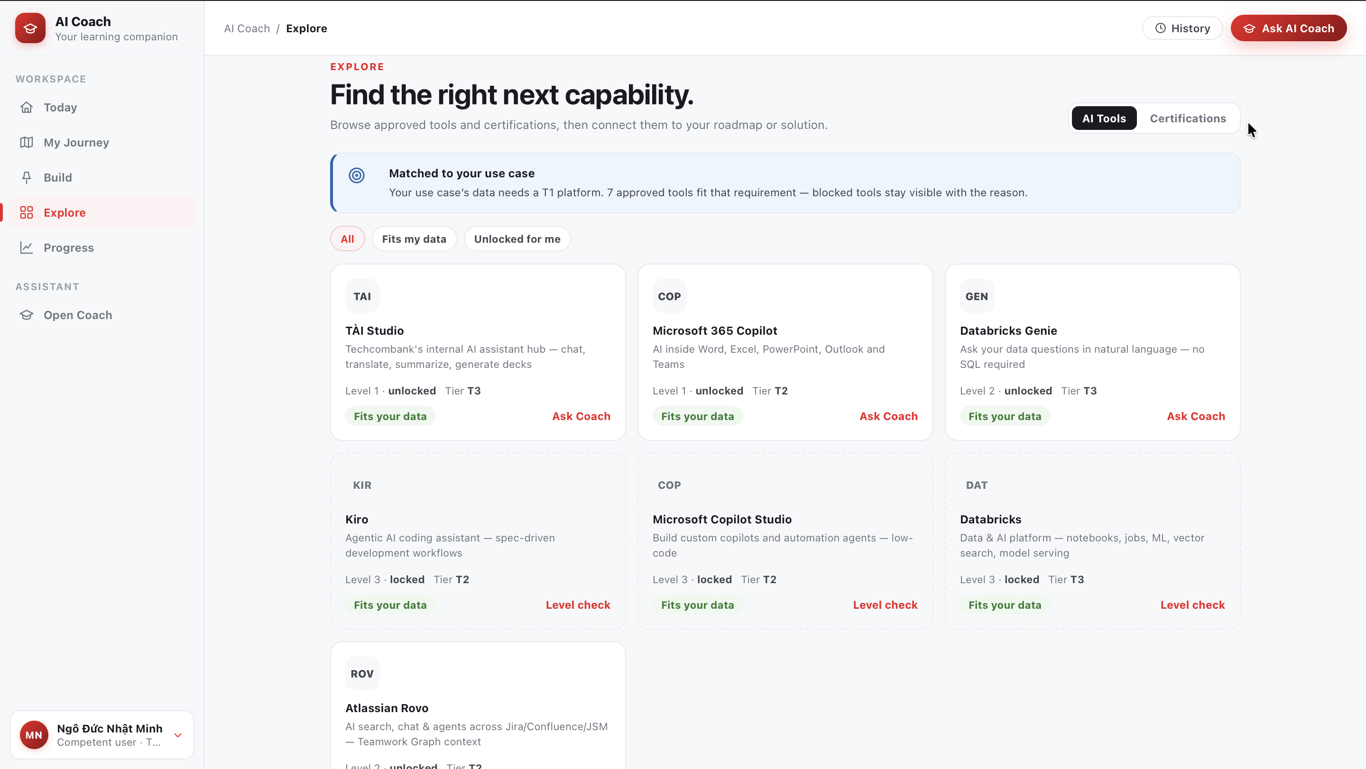
The list of AI tools available at Techcombank. Each tool card shows:
- The required level and locked/unlocked status.
- Tier (e.g. T2 / T3) and the tool group/category.
- Action buttons:
- Ask Coach — if the tool is unlocked, ask Coach for details on how to use it.
- Level check — if the tool is locked, take a check to reach the unlocking level.

Certifications
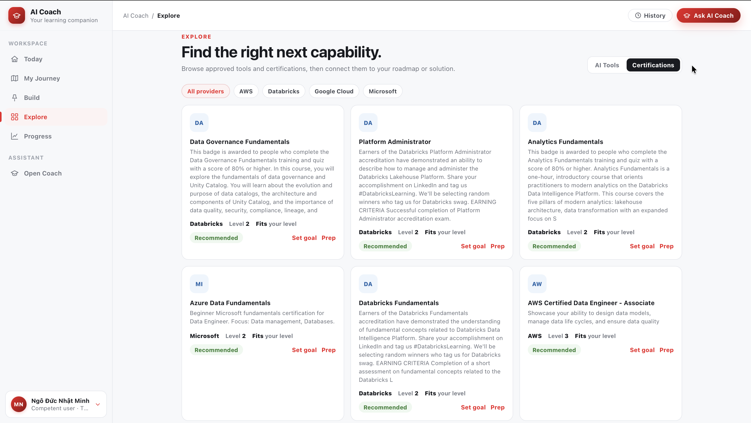
The list of certifications from Microsoft, Databricks, Google Cloud, AWS. Each card shows:
- The provider and the certification's level.
- Hint labels such as "Fits your level" / "Recommended".
- Action buttons:
- Set goal — set the certification as a goal (attached to My Journey).
- Prep — create a review path for that certification.
──────────────────────────────────────────────────

Progress — Learning progress
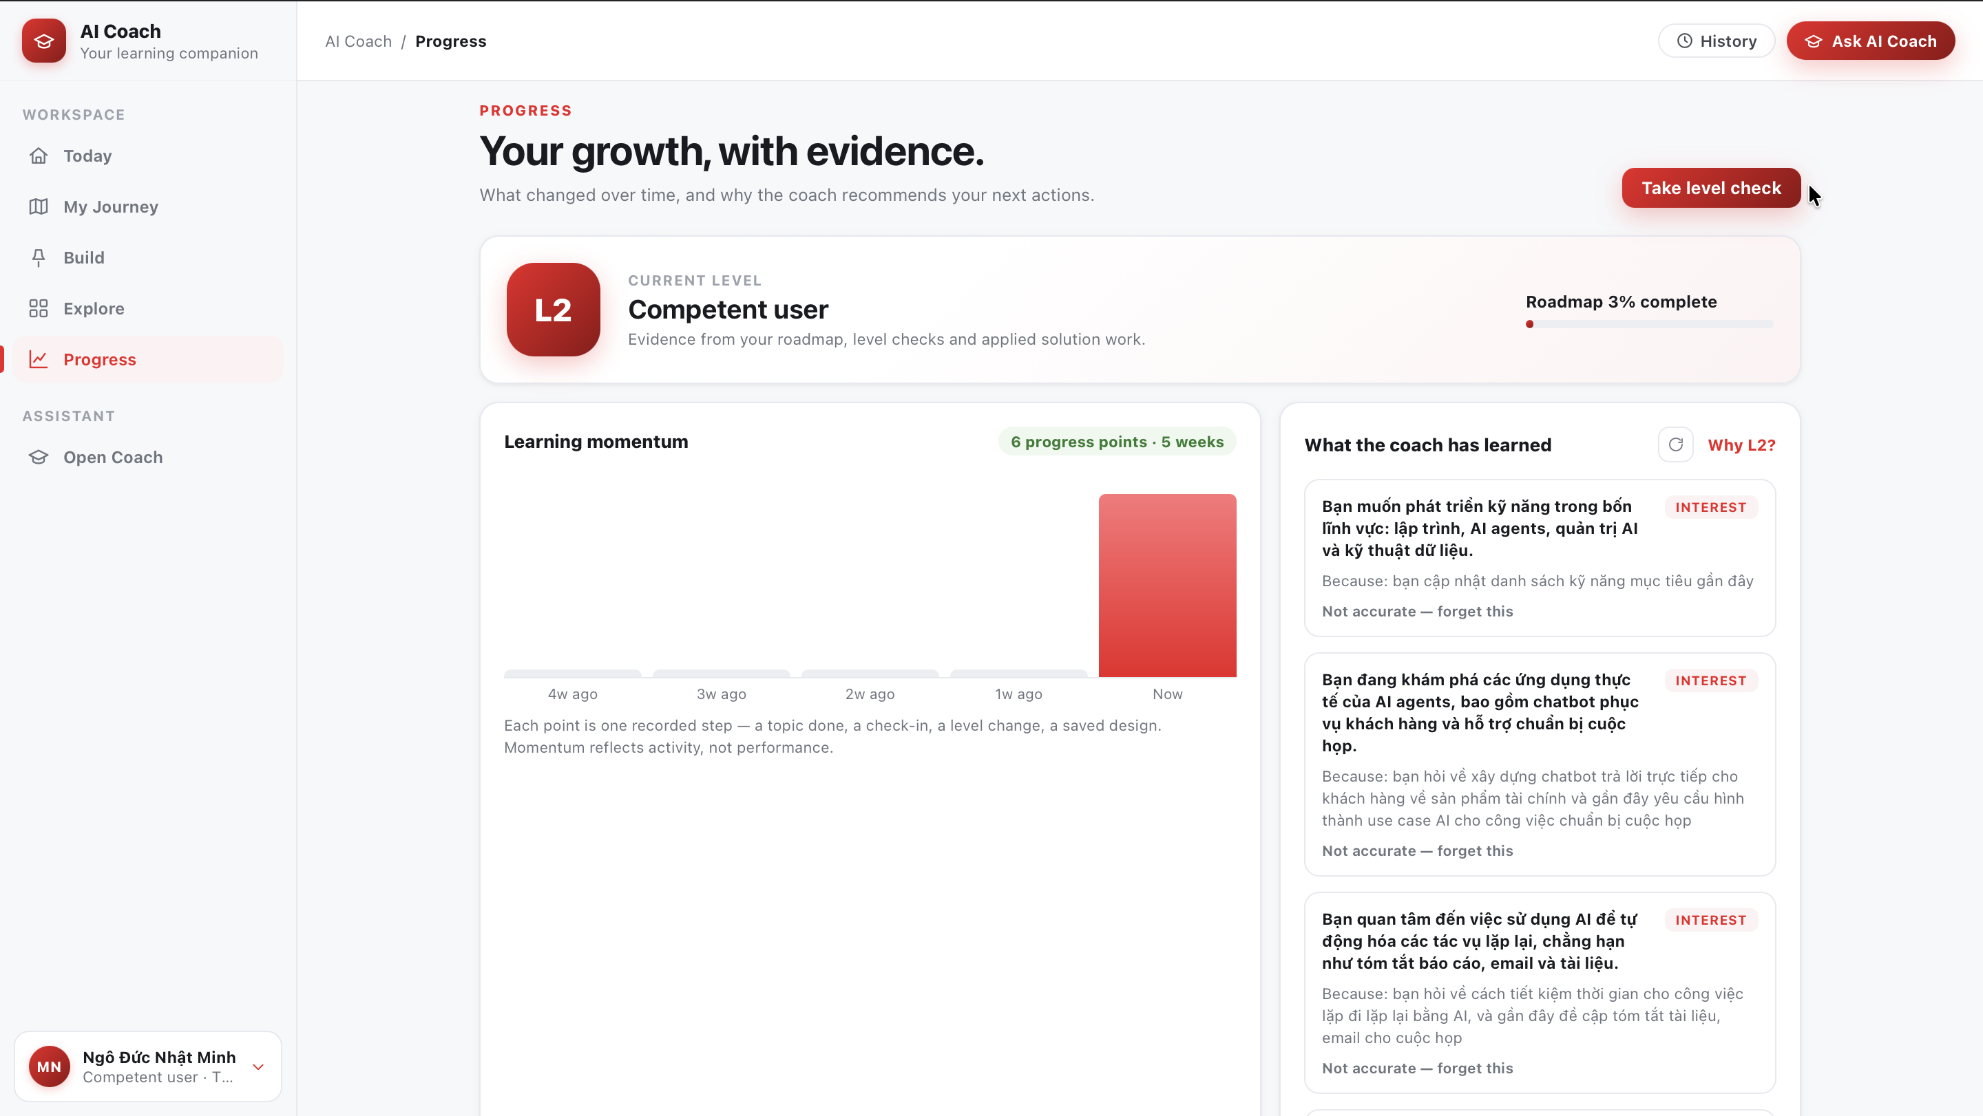
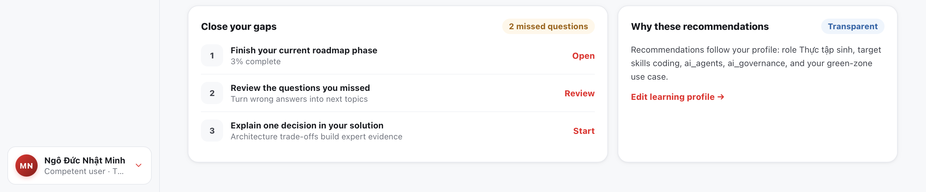
The Progress page ("Your growth, with evidence.") gives you an overview of your growth, with concrete evidence:
- Current level card — e.g. "L2 · Competent user", with your roadmap completion percentage and a Take level check button.
- Learning momentum — a chart showing your learning pace over time (it measures activity, not scores).
- What the coach has learned — things Coach has recorded about you, shown as labeled cards (INTEREST / PREFERENCE). Each card has a "Not accurate — forget this" button to ask Coach to forget incorrect information.
- Close your gaps — where you're weak: the number of questions answered incorrectly, with suggestions to "complete the current roadmap phase" and "review the ones you got wrong".
- Why these recommendations — a transparent explanation of why these recommendations appear.
- Edit learning profile — edit your learning profile.
──────────────────────────────────────────────────

Level system
AI Coach has 5 skill levels:
Level | Name | Short description
1 | Beginner | Understand AI basics, recognize applications, comply with policies
2 | Competent user | Use AI tools, interpret results to make decisions
3 | Expert | Design AI use cases, collaborate with technical teams
4 | Technical Professional | Develop & deploy AI models, manage the model lifecycle
5 | Revolution leader | Shape AI strategy, train teams across the organization
AI Coach recommends tools and content suited to your current level. If a topic is above your level, Coach lists the prerequisite knowledge and suggests a path to reach that content.

How to level up
- Your level rises through learning and practice: answering practice questions correctly, completing roadmaps, and continuous engagement.
- When you're ready, take a Level Check to officially level up. You can open a Level Check from several places: the Progress page, the Today page, or the welcome card in Open Coach.
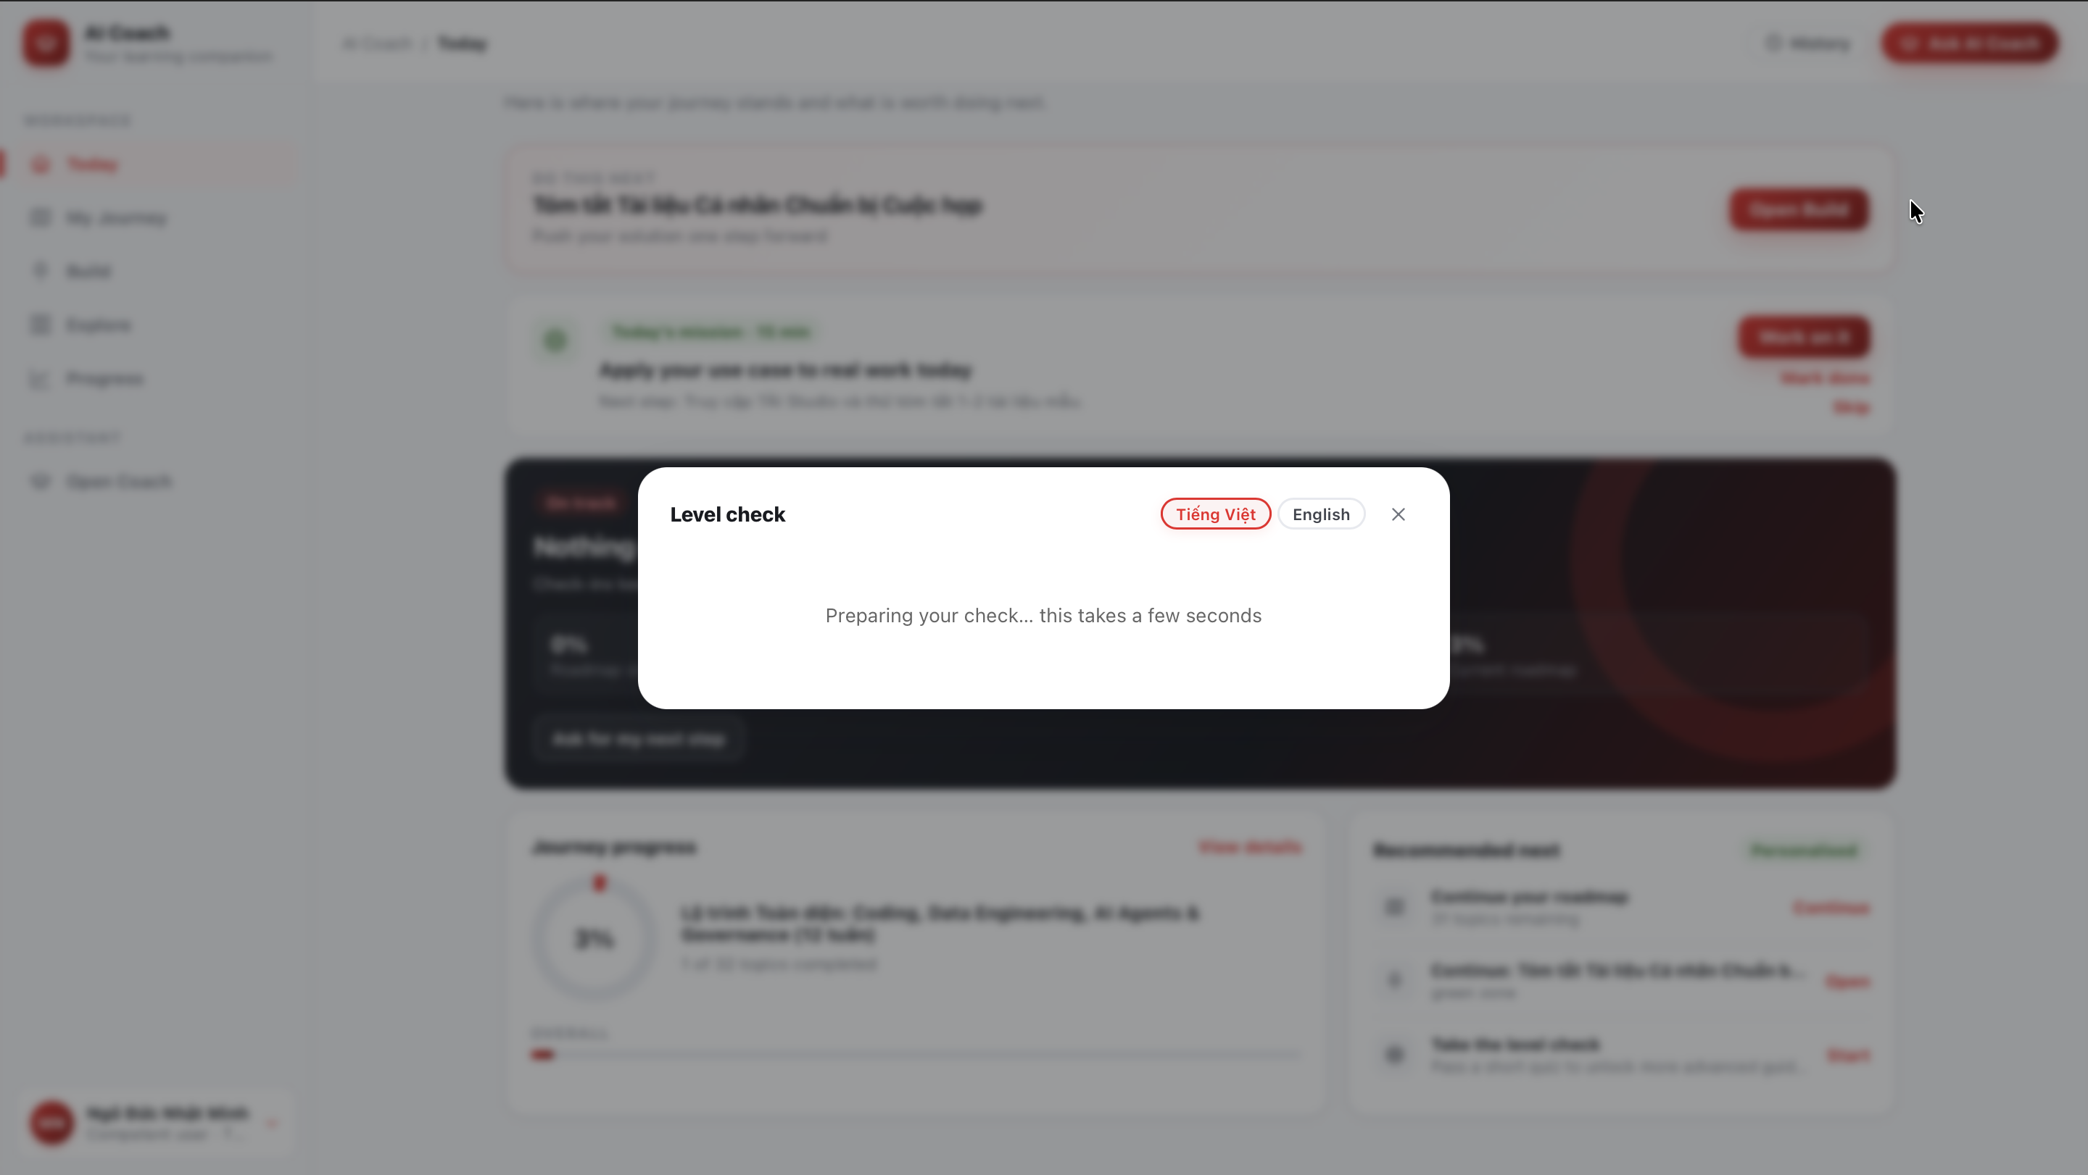
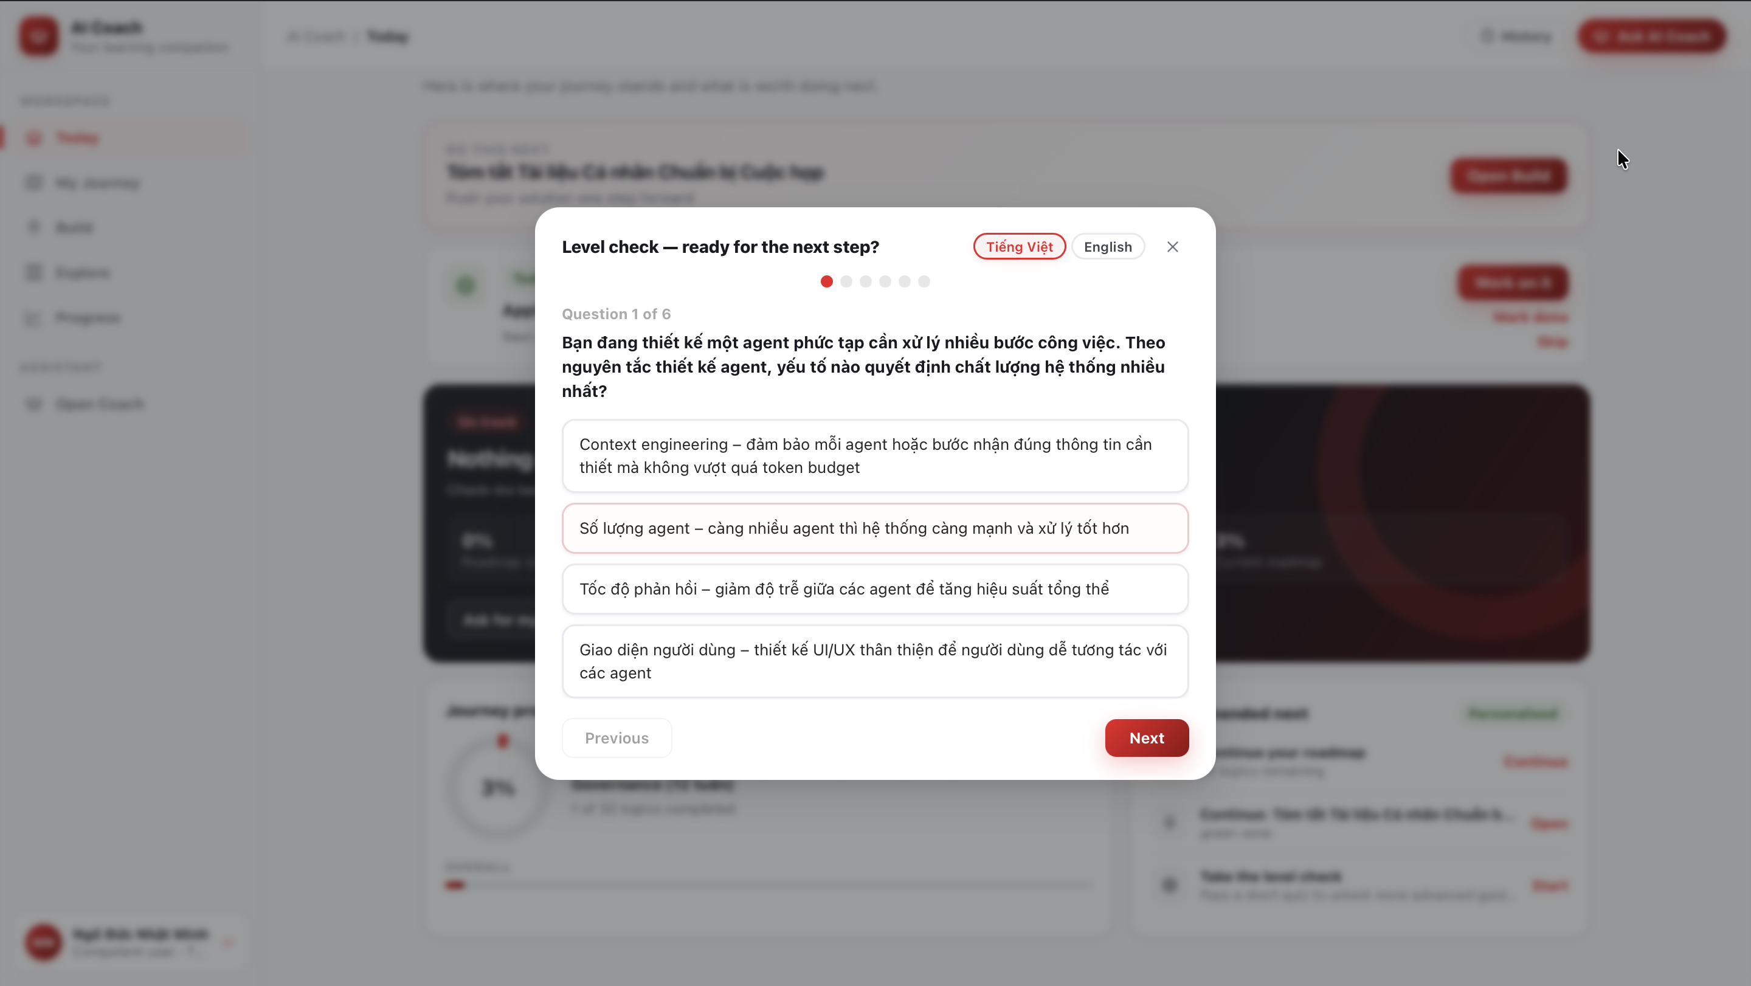
 | Level Check (scored) | Practice Quiz (practice)
Questions | 6 | Optional
Pass | ≥70% → level up by 1 | No effect on level
Fail | Locked for 4 hours | Retry immediately
──────────────────────────────────────────────────

Tips
- Describe your request as specifically as possible — "Explain RAG architecture" gives better results than "Explain AI".
- Pick the Coach voice that fits your purpose: Exam coach when studying for a Level Check, Delivery partner when planning a rollout, Concise expert when you need a brief answer.
- Type @ in the chat box to ask about a specific tool (e.g. @TÀI Studio).
- Use Build when you have a real task to improve — Coach will shape the use case and check the risk zone before you use it for real.
- Go to Progress → Close your gaps to review the questions you answered incorrectly.
- If Coach records something incorrect about you, use "Not accurate — forget this" in Progress to correct it.
- Practice regularly — level-up progress accumulates from every interaction.
──────────────────────────────────────────────────

Limitations
- AI Coach only supports content related to AI and technology at Techcombank.
- It does not provide medical, legal, or personal financial advice.
- The Safe-scope simulator results are preliminary reference only, not an official risk approval.
- Answers may be inaccurate — always verify important information.
──────────────────────────────────────────────────
Last updated at: 23/07/2026

